# Question 1

1. Perform addition on the following matrices.
2. $\left[\begin{matrix}1 & 2 \\ 3 & 4\end{matrix}\right]$ + $\left[\begin{matrix}1 & 2 \\ 3 & 4\end{matrix}\right]$
3. $\left[\begin{matrix}1 & 2 \\ 3 & 4\end{matrix}\right]$ + $\left[\begin{matrix}1 & 2 \\ 3 & 4\end{matrix}\right]$
4. $\left[\begin{matrix}3 & 5 \\ 2 & 7\end{matrix}\begin{matrix} 8 & 4 \\ 8 & 9\end{matrix}\right]$ + $\left[\begin{matrix}4 & 6 \\ 0 & 2\end{matrix}\begin{matrix} 1 & 2 \\ 3 & 8\end{matrix}\right]$
5. $\left[\begin{aligned}\begin{matrix}23 & 12 \\ 10 & 15\end{matrix} \\ \begin{matrix}3 & 6 \\ 9 & 11\end{matrix}\end{aligned}\right]$ + $\left[\begin{aligned}\begin{matrix}2 & 4 \\ 5 & 5\end{matrix} \\ \begin{matrix}2 & 3 \\ 5 & 7\end{matrix}\end{aligned}\right]$
6. Perform Subtraction on the following matrices.
7. A picture containing text, clock, watch, gauge

   Description automatically generated
8. A picture containing text, clock, watch

   Description automatically generated
9. A picture containing clock, orange

   Description automatically generated
10. A picture containing text, clock, watch

    Description automatically generated
11. Multiply A with B

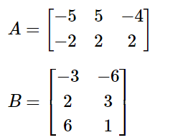

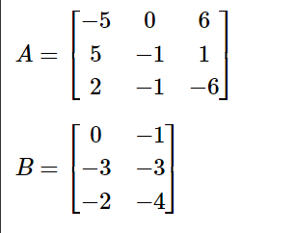

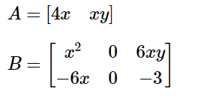

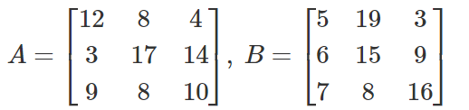

# Question 3

